Task – 1: View and assign roles
Step 1: Before assigning any roles, we create a resource group on which the role would be assigned, through this any resource under this resource group would be under the policies.
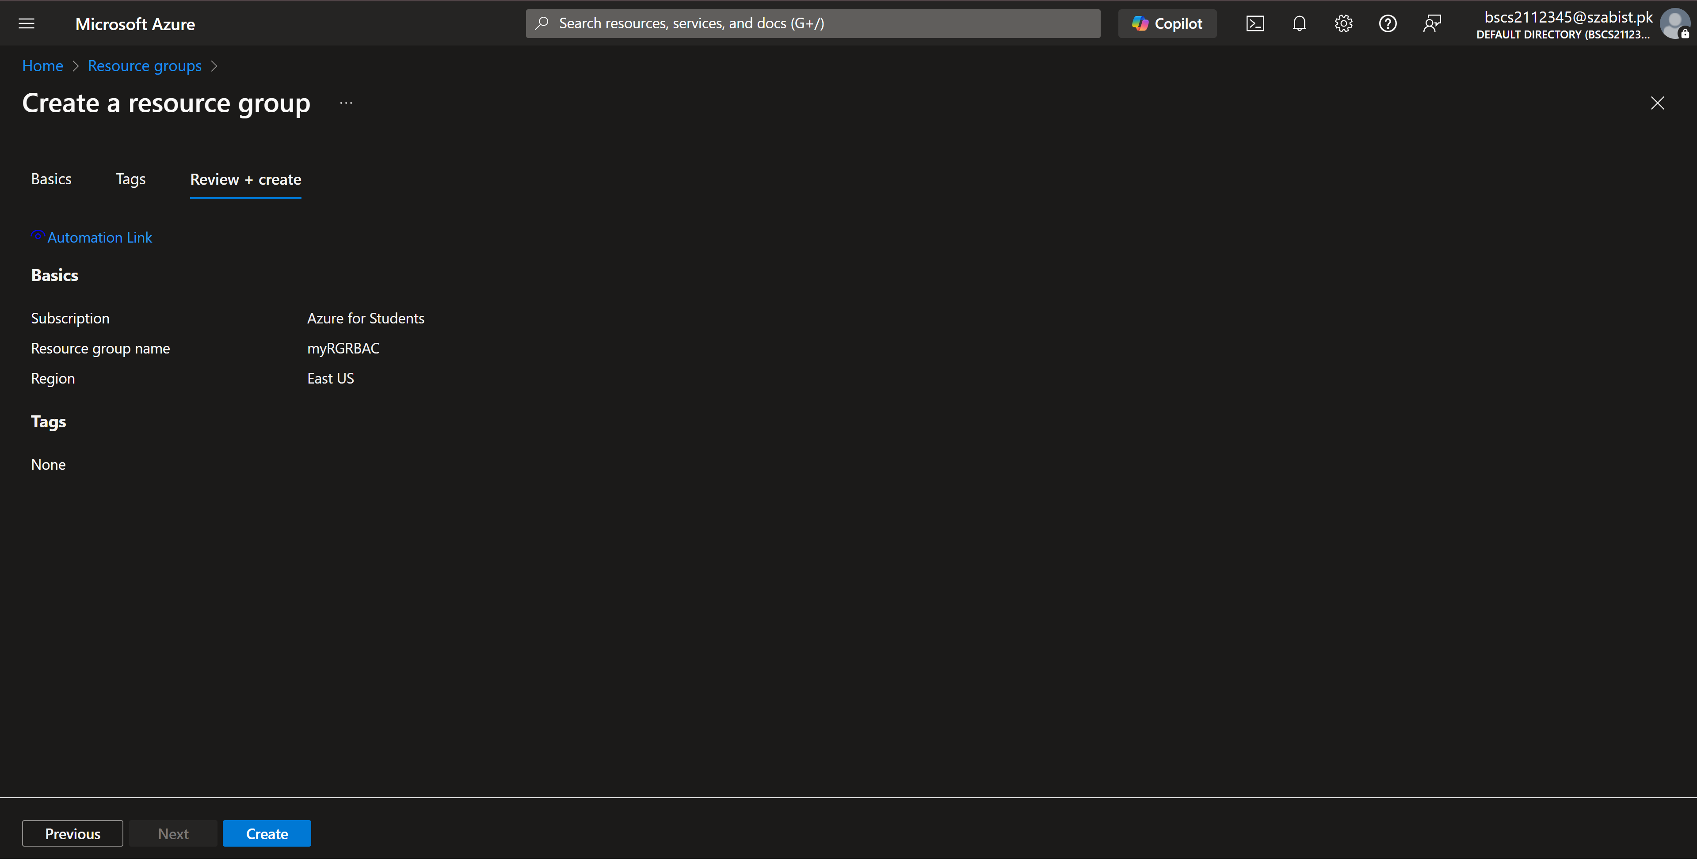
Step 2: The below screenshot highlights the default created role in azure, a long list to chose from where each role is based on different situations.
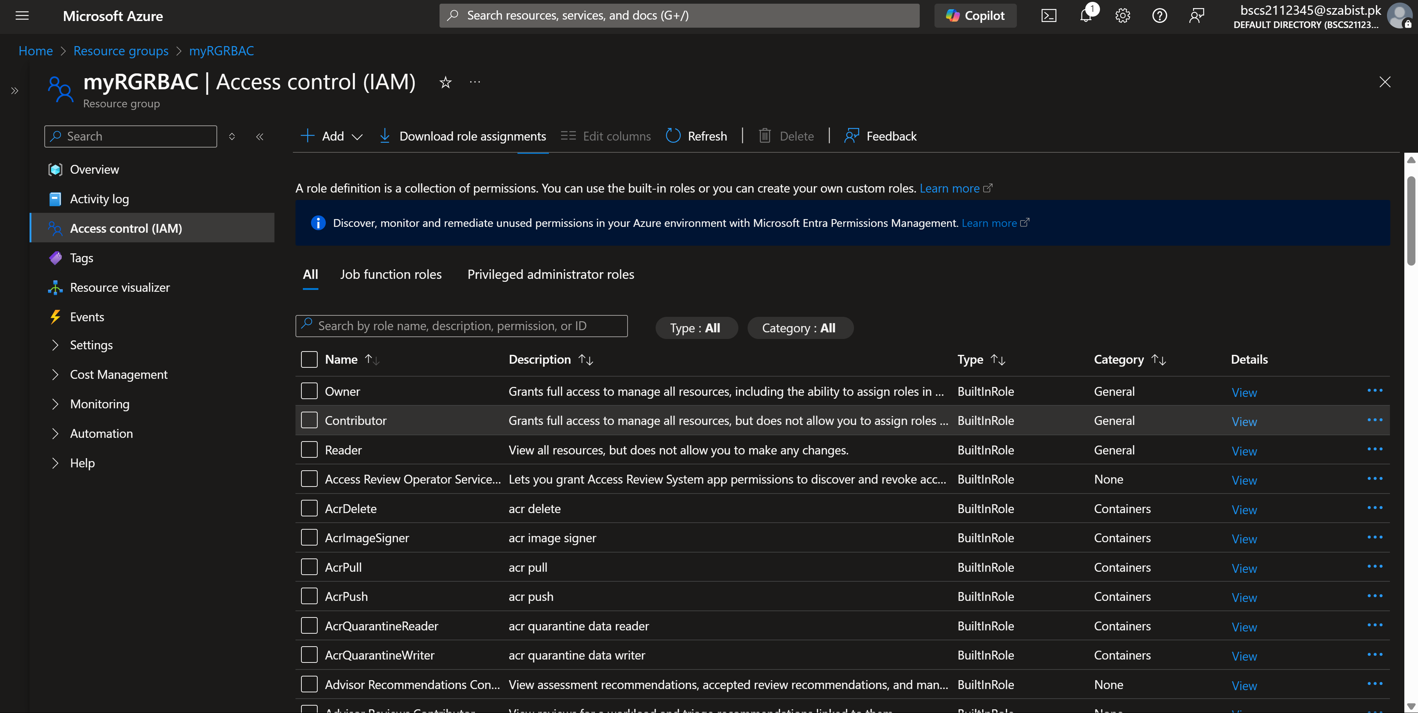

Step 3: Adding a new role assignment where the role is Virtual Machine Contributor.
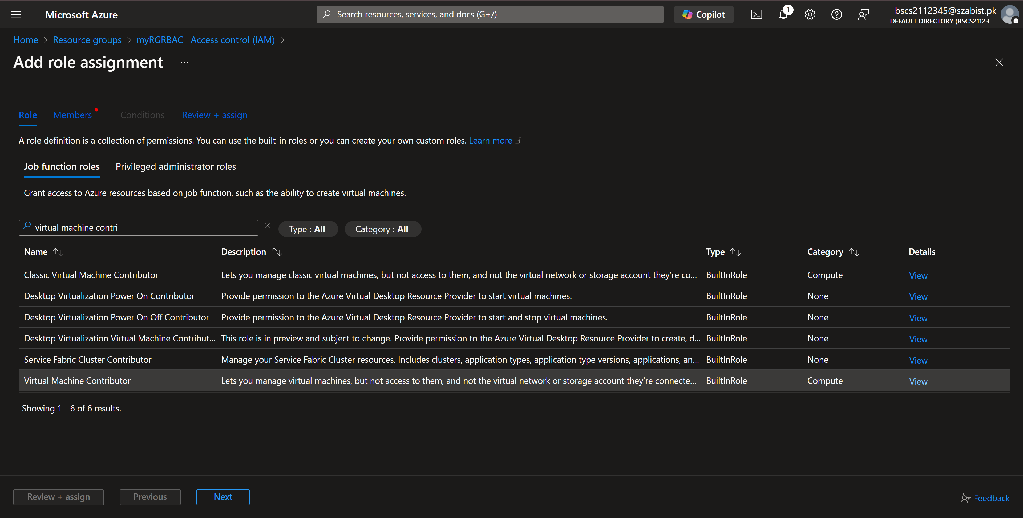
Step 4: After verifying the role assignment, it is assigned and below it’s scope which is the resource group or area on which the role is assigned.
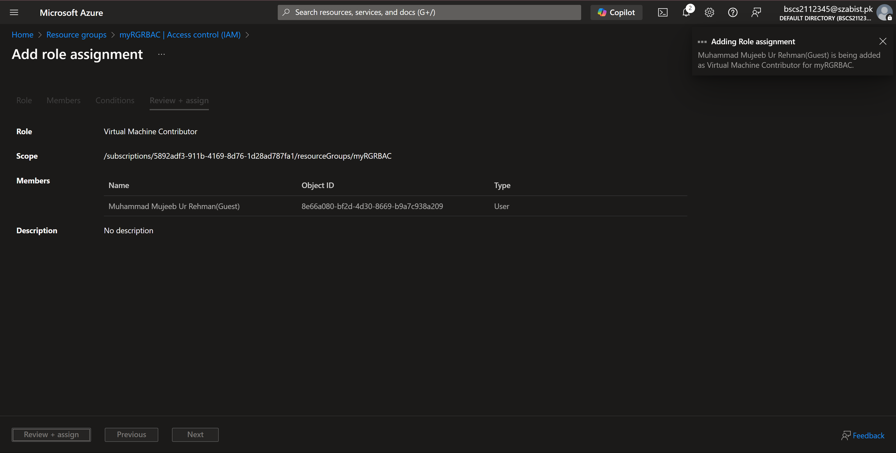

Task – 2: Monitor role assignments and remove a role
Step 1: The below image displays the activity log meny which can be filtered by the options available. 